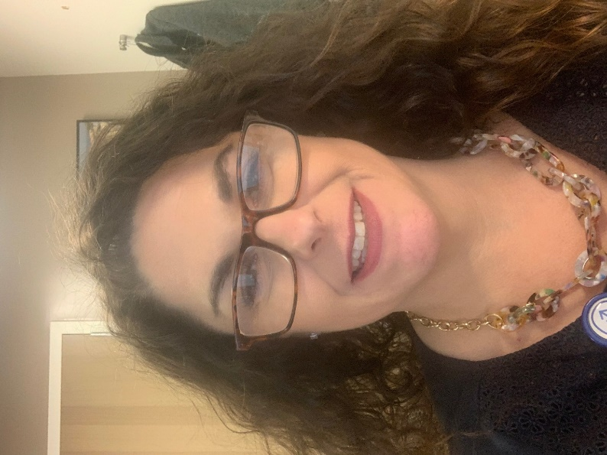

Dr. Giuliante has been offering aesthetic treatments in her community for several years.  She is credentialed by the **American Association of Facial Aesthetics**, and is happy to share her expertise with her neighbors.

Dr. Maryanne Giuliante is a triple board-certified nurse practitioner with over thirty years of clinical experience. Over these three decades, Dr. Giuliante has worked in world-class hospitals such as Columbia Presbyterian, New York University, and Memorial Sloan Kettering Cancer Center.  She has a Doctorate in Nursing Practice from Rutgers University, has degrees as both an Adult and Geriatric Nurse Practitioner. Dr. Giuliante is also a college professor at world class universities, teaching nurse practitioners getting Masters and Doctorate degrees, as well as undergraduate nurses seeking to become nurses.

Dr. Giuliante is also a certified bioethics consultant, helping health care teams and families make important decisions that are sometimes difficult. In addition, teaches medical ethics to other healthcare professionals and nursing students, ensuring integrity among the students she teaches and the professionals she works with.